SCaN TESTBED

EXPERIMENT PLAN

for

Intelligent Media Access Protocol for SDR-Based Satellite Communications

Worcester Polytechnic Institute

Alexander M. Wyglinski, WPI (PI), Sven G. Bilén, Penn State (Co-PI)

**DOCUMENT HISTORY LOG**

|  |  |  |  |
| --- | --- | --- | --- |
| **Status (Preliminary/Baseline/Revision/Canceled)** | **Document Revision** | **Effective Date** | **Description** |
| Baseline | 05/01/15 | 05/01/15 | Original version |
| Revision | 12/16/16 | 12/16/16 | Added cognitive engine architecture description |
| Revision | 1/19/2017 | 1/19/2017 | Updated timeline and scenarios description |
|  |  |  |  |
|  |  |  |  |
|  |  |  |  |
|  |  |  |  |
|  |  |  |  |
|  |  |  |  |
|  |  |  |  |
|  |  |  |  |
|  |  |  |  |
|  |  |  |  |
|  |  |  |  |
|  |  |  |  |
|  |  |  |  |
|  |  |  |  |

SIGNATURE PAGE

**Approved By:**

** 06/01/2015**

__________________________________ ______________________

Name: Alexander M. Wyglinski, Ph.D. Date

Title: Associate Professor

Organization: WPI

__________________________________ ______________________

**Diane C. Malarik** Date

SCaN Testbed Project Manager

NASA Glenn Research Center

Contents

1 Introduction 1

1.1 Purpose 1

1.2 Scope 2

2 Documents 2

2.1 Applicable Documents 2

2.2 Reference Documefnts 3

3 Experiment Definition 4

3.1 Objective 4

3.2 Experiment Concept, Definition and Design Summary 6

4 Experiment on-orbit execution description 21

4.1 Experiment Data Flow 21

4.2 Experiment Operational Scenario 22

4.3 RF Interface Characteristics Data Rate and Frequency Plan 24

4.4 Commands, Telemetry, and File Description 24

5 Management Plan 25

5.1 Experiment Point-of-contact 25

5.2 Experiment Sponsor 25

5.3 Agreement Mechanism (Space Act Agreement, Cooperative Agreement, SBIR Contract, etc.) 25

5.4 Roles and Responsibilities 26

5.5 Reporting Plan (Interface with the project) 26

5.6 Resources 26

5.7 Software Configuration Management Plan 26

5.7.1 Software Development Environment 27

5.7.2 Build Procedures 27

5.7.3 Source Code Version Control Tool 27

5.7.4 Controlled Delivery of Software 27

6 Experiment needs 28

6.1 Requirement Approach Overview 28

6.2 Experiment Activity Requirements 28

6.3 ScaN Testbed Project Requirements 29

7 Key Events Summary 29

7.1 Project Phases (Design, Development, Ground Test, On-Orbit Test) 29

7.2 Key Milestones (Including Reviews) 31

7.3 Deliverables 31

7.4 Dependencies 32

7.5 Ground Resource Test Schedule Plan 32

7.6 On-Orbit Experiment Schedule Plan 32

8 Experiment approach by phase 33

8.1 Development and Test Approach 33

8.1.1 Activity Description 33

8.1.2 Development and Test System Configuration 33

8.1.3 Resources Requested from ScaN Testbed 36

8.1.4 Equipment/Personnel Location 36

8.1.5 Schedule 37

8.1.6 Software Plan Information 37

8.2 Verification and Validation Approach 45

8.2.1 Activity Description 45

8.2.2 V&V System Configuration 46

8.2.3 Resources Requested from ScaN Testbed 46

8.2.4 Equipment/Personnel Location 46

8.2.5 Schedule 46

8.2.6 Software Plan Information 46

8.3 On-orbit Operations Approach 47

8.3.1 Activity Description 47

8.3.2 On-Orbit System Configuration 47

8.3.3 Resources Requested from ScaN Testbed 47

8.3.4 Equipment/Personnel Location 48

8.3.5 Schedule 48

8.3.6 Software Plan Information 48

8.4 Results Dissemination Phases 48

Appendix A Acronyms and abbreviations 49

Appendix B TBDs and TBRs 51

List of TBDs 51

List of TBRs 51

9 References 52

# Table of Figures

Figure 1-Experiment scenarios where the proposed Intelligent MAC protocol is expected to be tested. It consists of a link using the Near-Earth Network in S-band and links using the Space Network in both S- and Ka-band through ionosphere. 8

Figure 2- Detailed diagram block for scenario 1 describing adaptation control with feedback on forward link. 9

Figure 3- Detailed diagram block for scenario 1 describing adaptation control with feedback on return link. 10

Figure 4- Detailed diagram block for scenario 1 describing adaptation control without feedback on return link. 11

Figure 5- Detailed diagram block for scenario 1 describing adaptation control without feedback on forward link. 12

Figure 6- Detailed diagram block for scenarios 2 and 3 describing adaptation control with feedback on forward links. 13

Figure 7- Detailed diagram block for scenarios 2 and 3 describing adaptation control with feedback on return links. 14

Figure 8 - Detailed diagram block for scenarios 2 and 3 describing adaptation control without return on forward links. 15

Figure 9- Detailed diagram block for scenarios 2 and 3 describing adaptation control without feedback on forward links. 16

Figure 10-Main elements that compose the ScaN Testbed project. The ones marked are expected to be used in the Intelligent MAC protocol experiment. 17

Figure 11-Intelligent MAC protocol diagram blocks to be developed, implemented and tested in this experiment. The adaptation might occur after proper identification based on channel sensing and third party databases. 18

Figure 12- Diagram block of the proposed reinforcement learning elements within the feedback loop for a down-link pair with the receiver at ground and transmitter in space. 19

Figure 13- Hybrid learning engine using reinforcement learning and neural networks to achieve both online learning and system modelling. Knowledge management takes an important role in keeping only useful information for future use. 19

Figure 14 -Proposed cognitive radio engine architecture for proof-of-concept satellite communications. Channel state identification enables knowledge to be management after being acquired through a learning engine. 20

Figure 15 - Primary and experimental data paths expected to be used by the Intelligent MAC protocol experiment. Commands are sent exclusively by the primary path to turn the protocol on and off. It is expected its functionality will be completely autonomous. 22

Figure 16-Experiment Plan diagram block concept showing the relation between the experimenter needs and ScaN Testbed project activities for the experiment 28

Figure 17-Development configuration diagram block showing the general role of the experimenter team within the overall experiment process flow and development location. The main activities are algorithm development and software implementation. The experimenter’s team will be involved with all parts of the process flow. 35

# Table of Tables

Table 1-Applicable documents 2

Table 2-Reference documents 3

Table 3-Key milestones and expected completion dates 31

Table 4-NPR 7150.2A Requirements 37

Table 5 Acronyms 49

# Introduction

This program will develop an intelligent Medium Access Protocol (MAC) in order to improve the robustness of space communications systems, by using software-defined radios (SDR) for low margin data links operating during a dynamically changing channel, especially at low elevation angles. This protocol must be capable to deal with latency and feedback issues while mitigating the channel impairments by adapting the radio parameters according to the current channel conditions when necessary. We expect to develop prediction and learning techniques and to use third-party databases, when available, as inputs to an algorithm that determines the radio settings, e.g., actions, that maximizes the data link performance.

The R&D team is composed of members from Worcester Polytechnic Institute (WPI) and The Pennsylvania State University (Penn State). Commenced in November 2014, the project is expected to be completed by December 2016. The experiment will be conducted by the Space Communications and Navigation (ScaN) team at National Aeronautics and Space Administration (NASA) Glenn Research Center.

## Purpose

The ScaN Testbed SDR radios onboard the International Space Station (ISS) provide the unique opportunity to develop and test *in loco* such an intelligent MAC protocol. The main goal of the program is to design and implement an adaptive protocol capable of sensing and predicting the dynamic channel conditions based on its past performance and third-party databases, to determine the suitable radio parameters. This protocol will maintain the minimum performance of the data link between a ground station and an orbiting satellite or interplanetary spacecraft when facing poor channel conditions and improve the performance while under favorable channel conditions. Thus, it is expected that the ground-to-space link be not only more robust but also maintain communication longer in the case when the channel conditions become poor enough to limit transmissions.

Software-defined radio (SDR) technology has enabled numerous advances in wireless communications

technologies for both terrestrial and satellite-based communications. For example, several channel access and fading-mitigation technologies for spectrum sensing [1] and adaptive coding and modulation (ACM) [2] have been developed and tested using SDR prototypes. However, the next technological leap for SDR is expected to be the implementation of onboard cognition, which can potentially provide the SDR platform with environmental awareness across several Open Systems Interconnection (OSI) layers [3], real-time knowledge of the current channel conditions, status of its communicating nodes and the network, and assessment of its own available resources. Such information is very important for optimizing communications link performance.

Within the past 15 years or so, several optimization algorithms such as genetic algorithms [4] have been

applied to cognitive radios (CRs) [5]. These optimization techniques do not always converge and might take several hundred or even thousands of iterations, e.g. algorithm runs, until a stable solution is found. Changes in the environmental conditions would require another series of iterations to search for a new solution, increasing latency. Also, if these same scenarios repeat, the system is unable to use previous solutions given that it cannot learn. Learning is considered to the be cornerstone of artificial intelligence (AI). Therefore, CR systems must somehow consider its principles, thorough technique implementations, in order to leverage true CR capabilities.

This experiment is aligned with NASA’s Communication and Navigation Systems Roadmap – Technology Area 05, which focuses on cognitive radios in space that “*sense their environment, autonomously determine when there is a problem, attempt to fix it, and learn as they operate.*” This experiment is also one step in the direction of removing communication as a constraint for future missions and their critical phases, and emergency communications to “*enable safe and efficient human exploration and autonomous robotic space explorations.”*

The results will be used to assess the adaptive MAC protocol performance for the on-orbit SDRs, which will help in the design of future MAC protocols and mitigation techniques that can make use of the radio flexibility in terms of parameter reconfiguration.

## Scope

This experiment plan does not include the software management plan (SMP) associated with the software development and implementation activities. The SMP is a separate document titled: “Intelligent MAC protocol for SDR-based satellite communication – Software Management Plan”.

# Documents

This section lists the NASA/Government and non-NASA/Government specifications, standards, guidelines, handbooks, or other special publications applicable to the application of this document.

## Applicable Documents

Applicable documents are those documents that form a part of this document. These documents are referenced in this document and the specific references shall carry the same weight as if they were stated within the body of this document.

Table - Applicable documents

|  |  |
| --- | --- |
| **Document Number** | **Applicable Document Title** |
| GRC-CONN-PLAN-5006 | Experimenter’s Handbook |
| NPR 7150.2 | NASA Software Engineering Requirements |
|  |  |
|  |  |
|  |  |

## Reference Documefnts

Table -Reference documents

|  |  |
| --- | --- |
| **Document Number** | **Reference Document Title** |
| GRC-CONN-DOC-5022 Rev A | ScaN Testbed Flight and Ground System Description |
| JPL D-47937 | Operating Environment Operator’s Guide |
| D-63241 | Operating Environment Development Integrator’s Guide |
| JPL D-63258 | Space Telecommunications Radio System Operating Environment Development Environment |

# Experiment Definition

## Objective

**Statement of work**

The main objective of this program is to develop, implement, and test a proof-of-concept intelligent MAC protocol based on adaptive and predictive techniques for on-orbit SDR radios and to assess the achieved data link performance in terms of throughput improvement and increase in connection time before disruption, as well as multi-objective performance during different communications mission phases.

Additional objectives include the experimentation with prediction algorithms based on well-known techniques such as Kalman filters and its variants, as well as machine learning algorithms using past telemetry data such as received power levels and third-party data bases such as NOAA’s space weather forecast data.

The development phase also includes a research phase, during which modelling of the most common channel impairments will be done, such as slow and fast fading. These models will be used as a first resource to test the proposed algorithms, as well as to define the basic behavior of the protocol in terms of learning and decision logic to meet minimum performance requirements. One of the most interesting research scenarios is expected to be the performance evaluation of communication through the ionospheric plasma, when the channel imposes the most challenging scenario for low-margin systems operating at low elevation angles between Earth and a space radio.

Once the protocol is ready on ground (after development, implementation, and ground testing), it is expected to be tested in space for links between the on-orbit ScaN Testbed SDR and ground stations at Glenn Research Center (GRC) and White Sands.

Note that the experimenters’ team will attempt to implement this proof-of-concept prototype using all available resources, infrastructure, personnel, and facilities within the defined project period.

**Quantitative metrics**

The performance of this intelligent MAC protocol is expected to be measured through the following quantitative metrics:

* Relative power loss between transmitter and receiver
* Data rate (throughput)
* Bit error rate (BER)
* Latency
* Spectral efficiency
* Power consumption
* Bandwidth

**Comparison of objectives with the current state of the art**

Beyond implementing and testing the proposed MAC protocol for communication between a ground station and an on-orbit SDR and assessing its performance for a near-Earth link, we also must consider its performance while facing conflicting resource allocation while trying to optimize multiple objectives for links with radios in LEO or GEO orbits, and in deep space. Machine learning (ML) techniques have been studied with respect to their approach to CR, thus addressing the learning issue [1, 2, 3, 4]. Both approaches, optimization and ML, have been studied in order to determine how they can assist cognitive radio (CR) systems with respect to finding the best configuration parameter set, with the majority of research focused on spectrum management, including sensing techniques, for terrestrial links [4]. The scenario is the same for satellite links, with the majority of CR research focused on spectrum resource allocation [5, 6] and to the best of the authors' knowledge, almost none on radio resource management. We propose to employ techniques that leverage Kalman filters [1, 2, 3, 4, 5] for channel state detection such as the Interactive Multiple Mode (IMM) filters [6, 7, 8].

The MAC protocol specifies rules by which a frame is transmitted via the link. It aims to coordinate the frame transmissions of several nodes from a network meeting multiple access requirements, classified into channel partitioning, e.g., TDMA, CDMA, FDMA, and random access, e.g., CSMA/CD or CSMA/CA [15, 16]. They can also be implemented in a hybrid manner which affords the opportunity to explore a hybrid model that adapts over time to different aspects depending on the user needs and the channel conditions [10, 11].

Most research on adaptive MAC protocol has been done for ATM over satellite links [12, 13], adaptive FEC, and ACM for ATM over satellite links [14]. Theoretical approaches to adaptive schemes for satellite communications over fading channels using ACM and power adaptation have been done [15]. Nevertheless, ***this proposed effort aims at improving the current state of the art by developing and field testing a predictive and adaptive intelligent MAC protocol for a communication link between Earth and an SDR onboard ISS to overcome several space communication constraints based on link performance and space environment information***.

**Expected change in Technology Readiness Level**

This experiment should increase the TRL from 5 to 6, given that beyond the development and implementation of an intelligent MAC protocol for space-based and satellite communication networks, we also plan to demonstrate this new technology using the resources made available by NASA ScaN Testbed SDR radios. By the end of this experiment we expect to be able to provide cognitive space-based communication radios operating low-margin links at low elevation angles during critical mission phases with a MAC protocol that allows the radio to be aware of the current communication channel conditions and to react accordingly at the right time by changing some radio parameters.

**Alignment with ScaN Testbed project requirements and future NASA missions**

The primary objective of this experiment is to fulfill a ScaN Testbed project requirement by meeting some of the objectives described in “NASA Communication and Navigation Systems Roadmap” (Technology Area 05) listed as:

* High Priority:
  + 5.5.1 Radio Systems
* Medium Priority:
  + 5.3.1 Disruptive Tolerant Networking
  + 5.5.3 Cognitive Networks
* Low priority:
  + 5.2.5 Earth Launch and Reentry Communications

## Experiment Concept, Definition and Design Summary

**Experiment Concept**

The experiment concept is to test the performance of the proposed MAC protocol between a fixed station and the moving ScaN Testbed SDR. We are looking toward the scenario when reconfiguration might be done during periods of signal fading, especially those happening during low elevation angles of the ScaN Testbed antenna while tracking a TDRS satellite or low elevation angles for GRC ground station while tracking ScaN Testbed. Since multiple radio parameters are expected to adapt, different communications requirements will impose different metric goals that simulate different communications phases during real-world operation phases such as spacecraft launch, re-entry, streaming of multimedia content, power saving, cooperative communications, normal and emergency operations.

In addition to that, an even more interesting scenario is the performance analysis for a scenario with this same elevation angle conditions while the LOS goes through a non-uniform ionospheric region. This happens when the LOS goes across an imaginary ionospheric volume located between 20:00 and midnight local time, when ionospheric bubbles usually form giving rise to ionospheric gradient densities [16].

Such experiment will allow us to better understand the efficiency of an adaptive protocol for space-based cognitive radios to be implemented in future missions allowing better communication performance, especially during critical phases such as low-margin systems communicating during varying channel conditions.

**Experiment Definition**

As mentioned above, we will be testing radio parameter reconfiguration through an intelligent MAC protocol for three different and independent scenarios, for which we will be using different on-orbit radios, frequency bands, and ground stations, but all using the ScaN Testbed as the second communicating node.

During this experiment we expect to implement and test algorithms to operate at S- and Ka-bands. These experiments are split into four different scenarios, shown in Fig. 1. Each experiment scenario will occur individually, and are not expected to occur at the same time. Additional description of each possible experiment scenario in terms of closed- and open-loop, as well as adaptation in the forward or returning links are depicted in Figure 2­­–Figure 9, except for Scenario 4 which does not use the ScaN Testbed.

For experiments in the S-band we will use the JPL SDR radio. Also we plan to use three different antennas. As shown by Figure 1, for scenario 2 that operates at Ka-band, we will use the Ka-HGA antenna on the ScaN Testbed. For scenarios 3 and 1, which both operate at S-band, we will use the SN-LGA and GN-LGA antennas, respectively.

Additionally, we might use two ground stations, one available at White Sands and another at GRC. Depending on the ground-station SDR hardware available during the experiment time frame, full-link reconfigurability or half-link reconfigurability will be achieved.

The ideal case for all the three scenarios is to have all the ground stations equipped with SDRs compatible with the radios they will be communicating with, allowing link adaptation in both directions. If only a reconfigurable transmitter or a reconfigurable receiver is available at the ground station, the link will be adapted in only one direction.

The experimenters understand that the downlink is most important for NASA applications. Thus, we expect to test the protocol for the downlink first, using the uplink as a feedback control for the protocol using the reconfigurable SDR receiver available at White Sands and GRC ground stations. After the successful implementation and testing of the adaptive protocol for the downlink, we expect to implement and test it in the uplink if there is any reconfigurable SDR transmitter available in these ground stations.

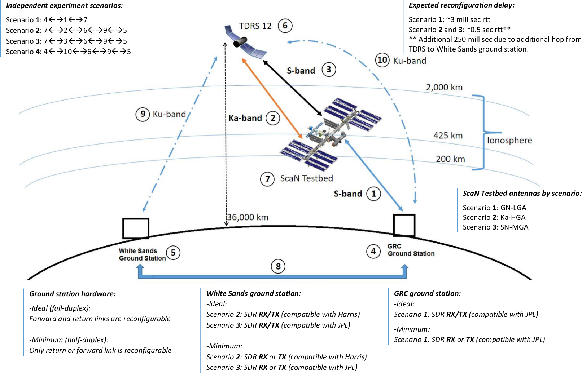

Figure 1-Experiment scenarios where the proposed Intelligent MAC protocol is expected to be tested. It consists of a link using the Near-Earth Network in S-band and links using the Space Network in both S- and Ka-band through ionosphere.

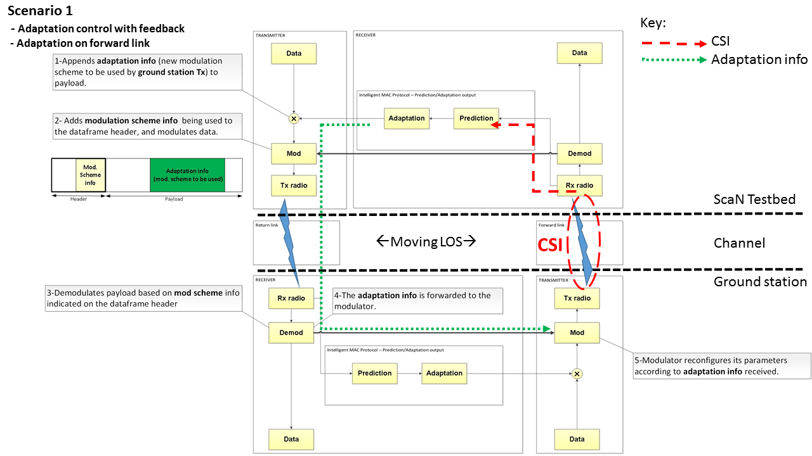

Figure - Detailed diagram block for scenario 1 describing adaptation control with feedback on forward link.

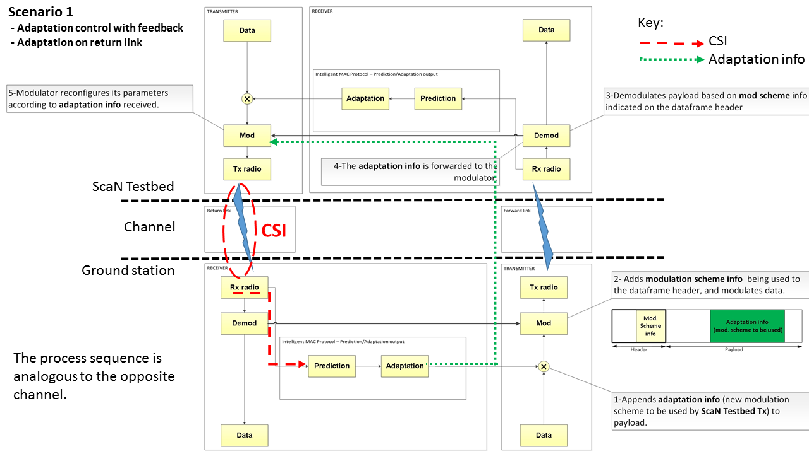

Figure - Detailed diagram block for scenario 1 describing adaptation control with feedback on return link.

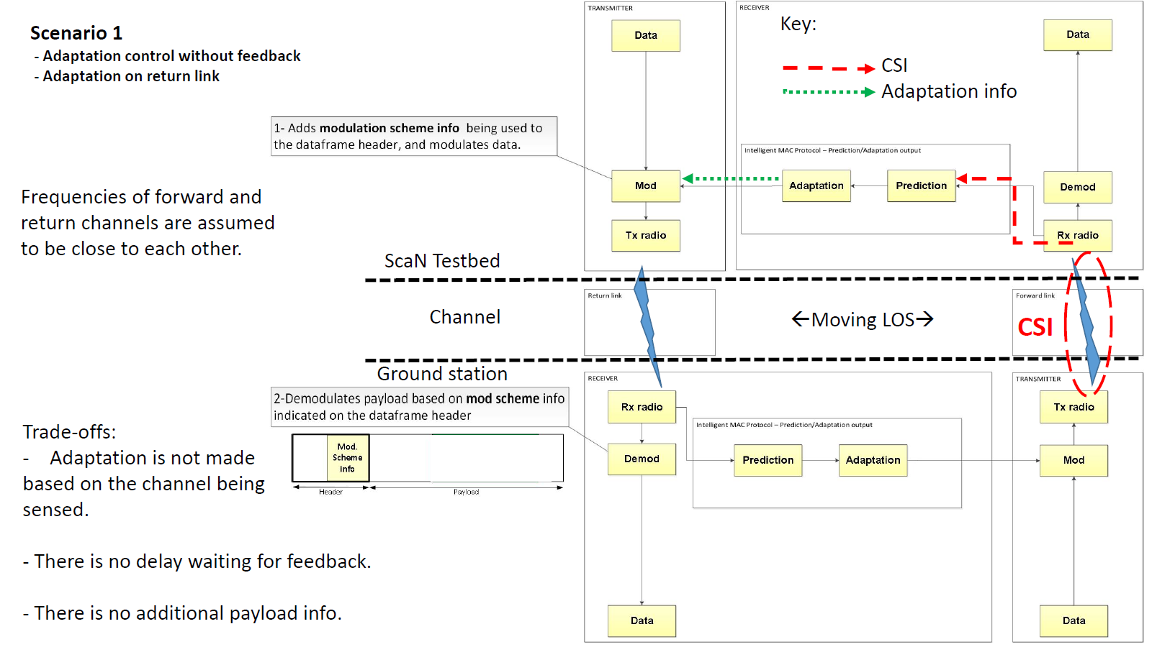

Figure - Detailed diagram block for scenario 1 describing adaptation control without feedback on return link.

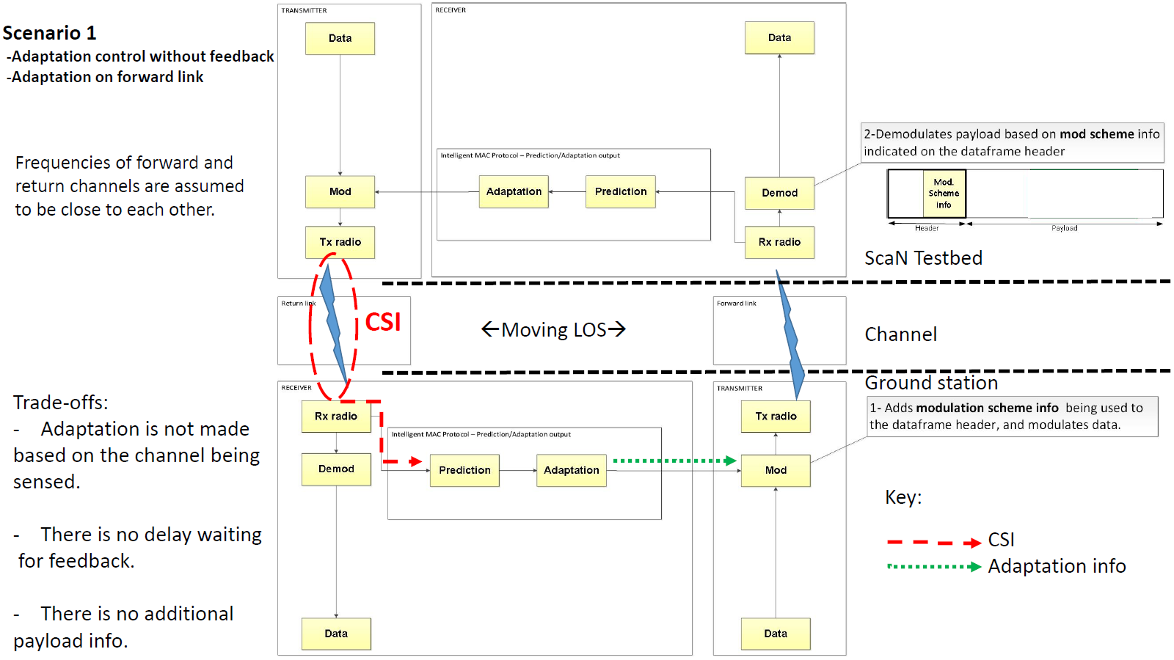

Figure - Detailed diagram block for scenario 1 describing adaptation control without feedback on forward link.

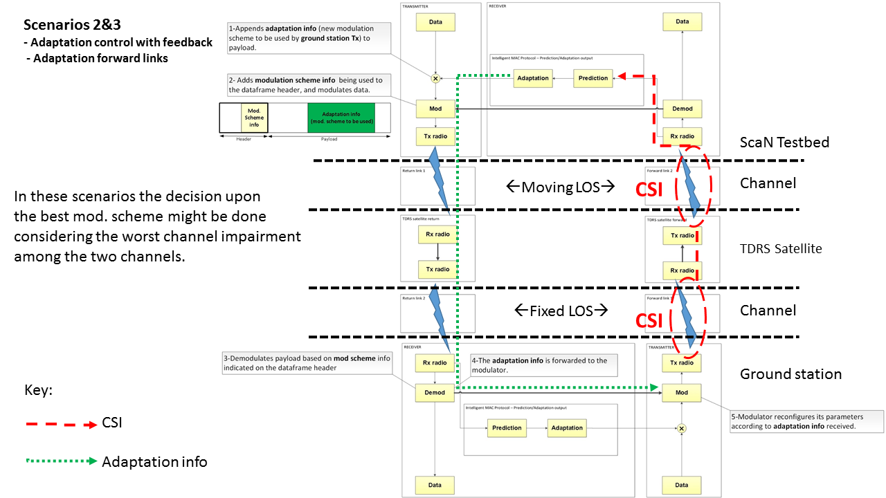

Figure - Detailed diagram block for scenarios 2 and 3 describing adaptation control with feedback on forward links.

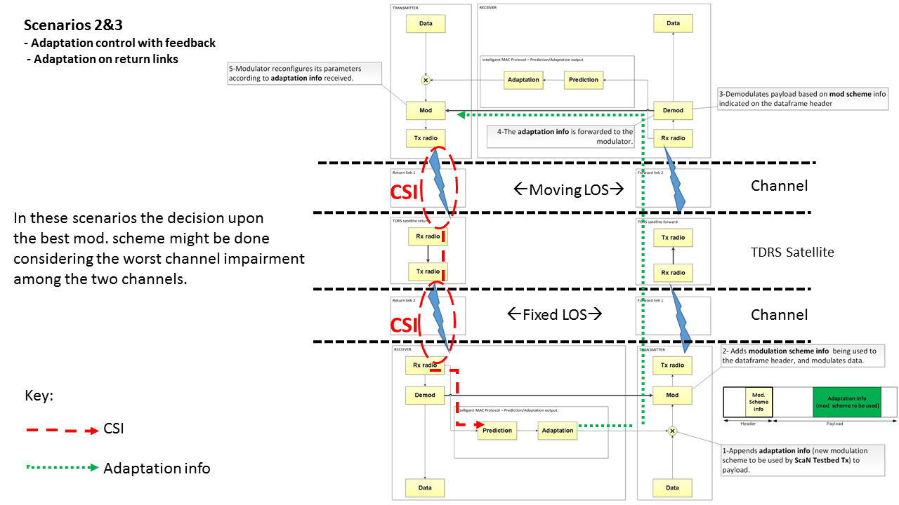

Figure - Detailed diagram block for scenarios 2 and 3 describing adaptation control with feedback on return links.

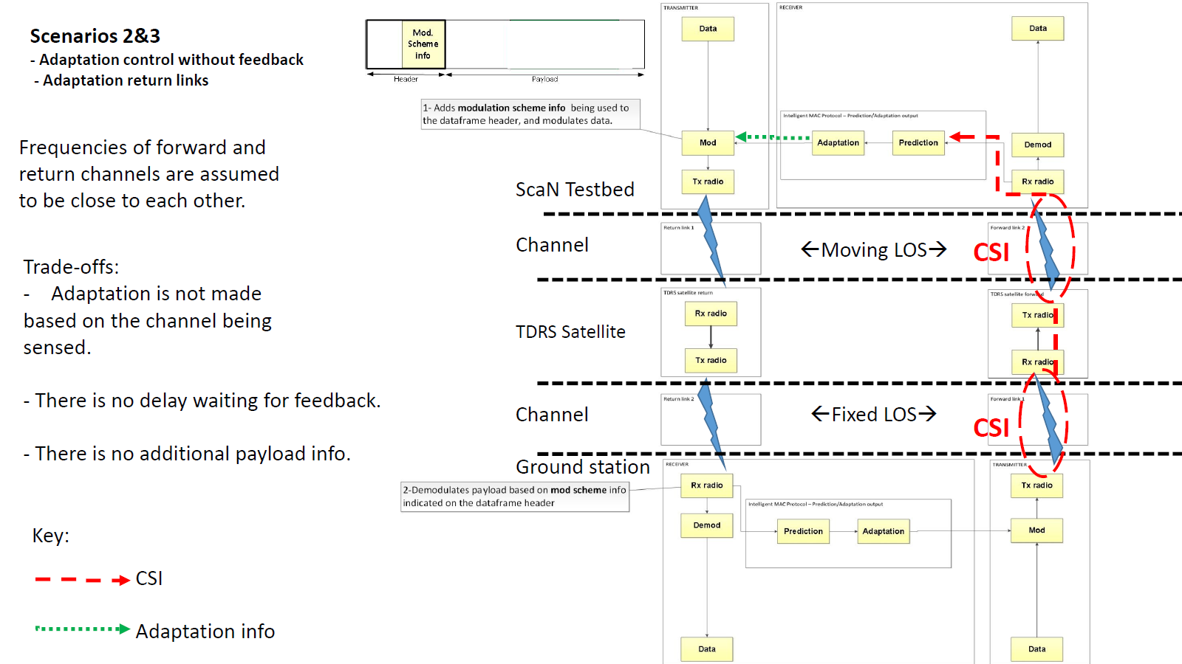

Figure - Detailed diagram block for scenarios 2 and 3 describing adaptation control without return on forward links.

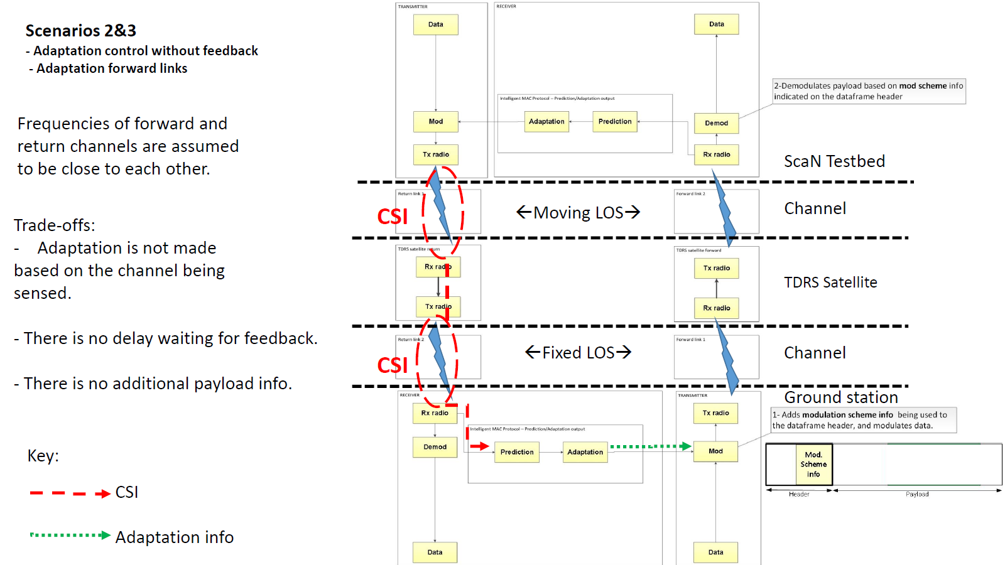

Figure - Detailed diagram block for scenarios 2 and 3 describing adaptation control without feedback on forward links.

**Design Summary**

The ScaN Testbed elements to be used in this experiment are highlighted in Figure 10. Since we expect to perform reconfiguration in one of the ScaN Testbed radios during each experiment using one of the reconfigurable radios available at the ground stations, we request use of an interface, a ground station for reception and transmission of telemetry information, and as a performance analysis measurement point, the on-orbit radio from JPL.

ISS

SCAN Testbed

Experiment Interface

External Systems

Ground System

GD-SDR

Avionics

Experiment Equipment

CONNECT

Control Center

NISN

WSC

RTN-IF

WSC

Legacy

Service

JPL SDR

TDRSS

RF

S-band DTE

= Experiment Element (e.g. sw, fw, hw, component)

Harris

Figure -Main elements that compose the ScaN Testbed project. The ones marked are expected to be used in the Intelligent MAC protocol experiment.

The higher level intelligent MAC protocol diagram block is shown in Figure 11. The basic approach consists of a sensing mechanism that uses telemetry data reported from other nodes, such as their received power levels as well as historic information from third-party databases. Next, a predictor uses the past information to predict the value of some parameters in a near future time by correcting its own parameters using feedback. The decision logic receives the predicted values and, based on the link performance requirements, decides upon the need for adaptation and when it should occur.

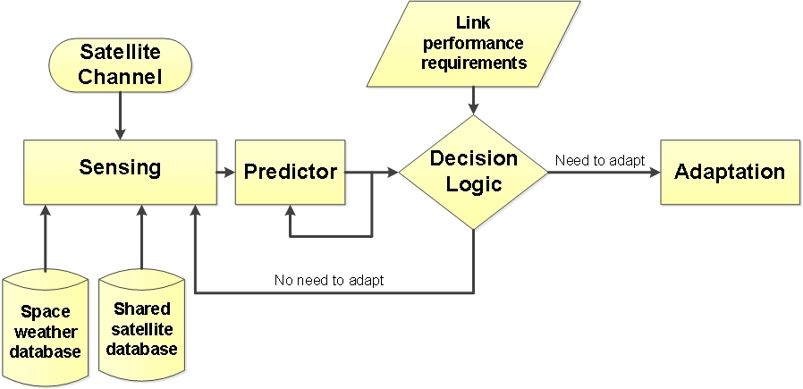

Figure -Intelligent MAC protocol diagram blocks to be developed, implemented and tested in this experiment. The adaptation might occur after proper identification based on channel sensing and third party databases.

During radio adaptations, the system can also learn the system behavior while the channel dynamically changes, as well as build a model of the decision logic seeking to decrease the cost of trying multiple actions, e.g., radio parameter sets, in parallel and/or to operate autonomously based only on the learning acquired so far, something that might be useful during emergency operations when learning is not possible due to lost of the feedback channel for example. Figure 14 illustrates the proposed cognitive engine architecture, a lower level perspective of the architecture shown by Figure 11.

The learning engine is expected to improve overall communications system performance during different communication phases. For each phase, conflicting goals require that multiple resources be optimally allocated. Proof-of-concept machine learning algorithms customized to deal with multi-objective resource allocation in the field of space communications are expected to be tested in-orbit, in this case within a link between the ScaN Testbed and NASA’s GRC ground station. An initial proposed architecture is a modified version of the classic Reinforcement Learning algorithm, as shown in Figure 12.

In order to manage the knowledge acquired through the learning engine, the channel state detector will have an important role in leaning classification for future use, as well as for decision-making modeling. These state classifiers are expected to be developed based on Interactive Multiple Mode (IMM) filters, which make use of a bank of Kalman filters, each modeling a specific channel behavior encountered through the spacecraft mission.

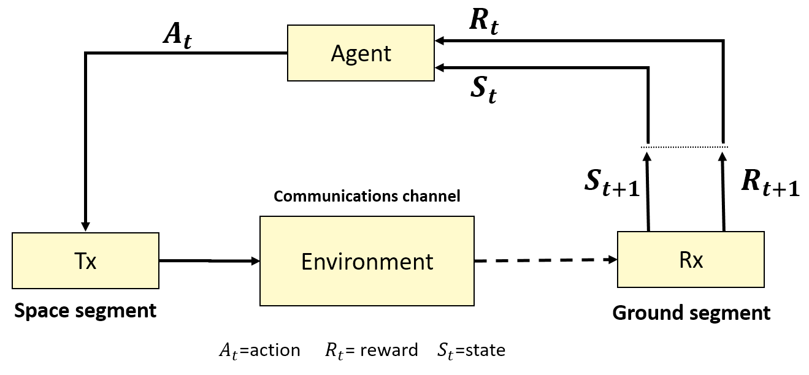

Figure - Diagram block of the proposed reinforcement learning elements within the feedback loop for a down-link pair with the receiver at ground and transmitter in space.

Seeking to optimize the learning and the overall communications performance, hybrid machine learning techniques might allow for action cost predictions while building models for future usage during autonomous operations. Our team expects to experiment with reinforcement learning and neural networks, as illustrated by Figure 13

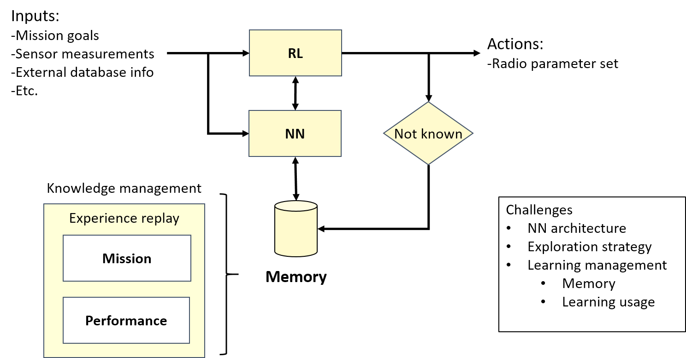

Figure - Hybrid learning engine using reinforcement learning and neural networks to achieve both online learning and system modelling. Knowledge management takes an important role in keeping only useful information for future use.

Due to resource constraints of the SCaN testbed, collecting sufficient training data for the cognitive engine is a non-trivial task. In order to supplement the collected data, the team will investigate methods to generate additional training data. In particular, Generative Adversarial Networks (GANs) appear to be promising. Should any methods appear promising, further operational details will be provided.

The knowledge base memory size will require some sort of compression, due to its physically limited size. The team will investigate online and incremental machine learning techniques that use an implicit representation of the knowledge base, allowing for a fixed memory size without forgetting previous knowledge. This has the added benefit of providing more flexibility within nonstationary environments. Techniques will be compared to a more standard moving window-based method by looking at improvements in execution time and prediction errors. Techniques that are an improvement on the window-based method in simulation will be tested on-orbit.

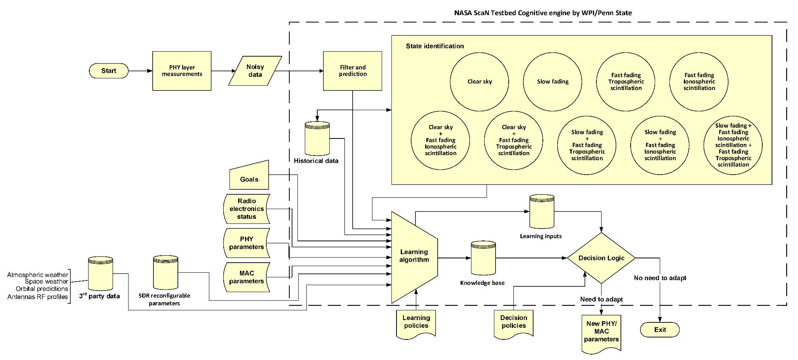

Figure -Proposed cognitive radio engine architecture for proof-of-concept satellite communications. Channel state identification enables knowledge to be management after being acquired through a learning engine.

# Experiment on-orbit execution description

## Experiment Data Flow

For this experiment we expect to use both primary and experimental data paths as shown in Figure 15. The primary path will be used to send the FPGA images for the radios containing the implementation of the proposed intelligent MAC protocol and to receive telemetry information of the flight system, such as transmitted and received power levels and the radio parameters being used during the experiment.

The experimental path will be used to transmit data. The performance of the experimental path will be evaluated in terms of the efficiency of the adaptation protocol using the metrics mentioned above. Depending on the antenna and frequency band being used, a different experiment path might be used. Considering NASA’s Near Earth and Space network topologies, the experiment is divided into two experimental path scenarios, shown in Figure 1. The first one considers the GRC ground station as the fixed node, thus communication is achieved by a direct ground-to-space link. The second scenario considers the TDRS satellite as the fixed node and the link of interest is between TDRS and ScaN Testbed.

The proposed algorithm is expected to be tested on three different experiments as follows:

* S-band/JPL SDR:
  + Two experiments may leverage the SCaN Testbed’s by using JPL SDR radio through the Near Earth Network between GRC GS and the ISS through the testbed’s S-band GN-LGA antenna.
* Ku-band/TDRS
  + Uses Space Network comprised of one NASA TDRS satellite to communicate between White Sands and Glenn Research Center ground stations.

For the experiment links going through a TDRS satellite (scenarios 2 and 3), the adaptation will be done considering the current worst performance of the two hops for each forward and return links. The hop between the SCaN Testbed and the TDRS satellite is expected to be more susceptible to ionospheric scintillation, especially at very low elevation angles for the ScaN Testbed antenna. The ionospheric scintillation is also expected to be more intense for the LOS crossing a non-uniform ionospheric region ranging from ±40˚ latitude and between 20:00 p.m. and 12:00 a.m. local time as longitude limits [16]. The hop between the TDRS satellite and the ground station, is expected to be more susceptible to rain fading due to the usage of Ku-band. Also, these two scenarios involve a round-trip delay of 0.5 seconds approximately due to the relative distance of the TDRS satellite and the ScaN Testbed and ground station, that might increase by the amount of varying network traffic and radio parameter adaptations.

Due to technical limitations, experiments on scenarios 2 and 3 are not expected to be tested on-orbit. Instead, scenario 4 is expected to be tested in-order to allow the experiment to occur at a different frequency band. Also, scenario 1 is expected to allow on-orbit testing of adaptation on the return link in both closed- and open-loop, as illustrated by Figures 3 and 4, respectively.

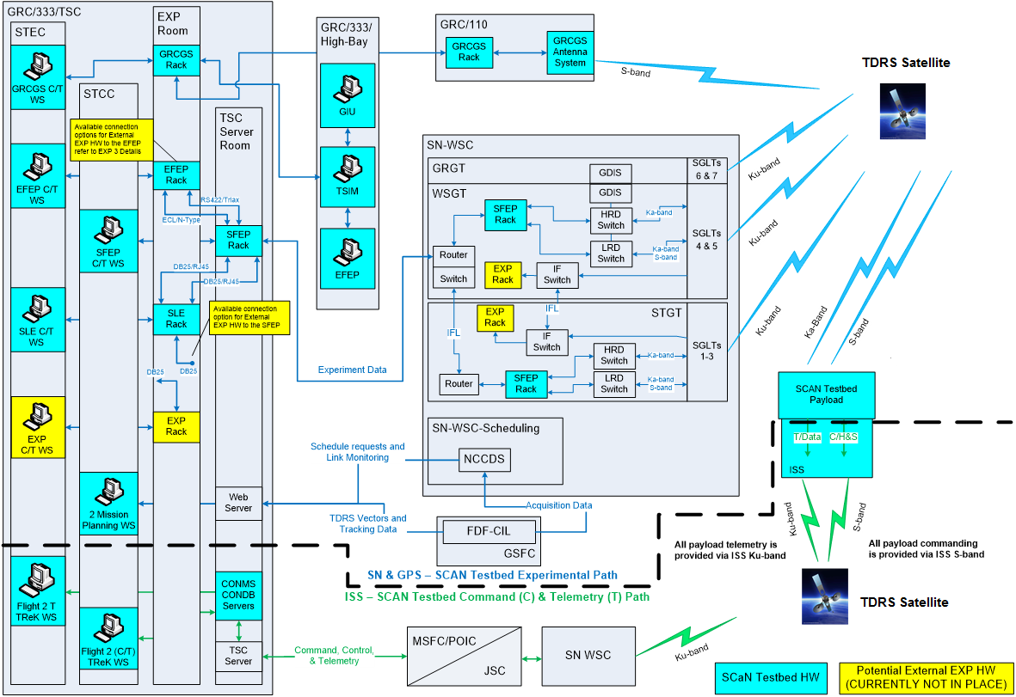

Figure - Primary and experimental data paths expected to be used by the Intelligent MAC protocol experiment. Commands are sent exclusively by the primary path to turn the protocol on and off. It is expected its functionality will be completely autonomous.

## Experiment Operational Scenario

In this subsection we assume that the radios are powered, initialized with the FPGA image files already loaded on the radios, and ready to transmit and receive.

In order to assess the improvement of the proposed protocol, all the experiments to be described below must be performed with the proposed adaptive protocol turned off and this is a requirement for each of the three scenarios. To compare performances, it is desired that the LOS geometries for the tests with the protocol off and on be similar in terms of location of the ISS with respect to the other communicating node. As mentioned above, depending on the SDR hardware available to the ground station during of the experiment run, forward and return, or just one of them will be reconfigurable.

Since we have three main different scenarios we describe the details individually according to Figure 1:

**Scenario 1)\*** GRC ground station 🡨🡪 S-band 🡨🡪 ScaN Testbed JPL radio

Using GRC as the ground station, the communication link uses the ScaN Testbed JPL radio and S-band GN-LGA antenna. A data file will be transmitted cyclically during the entire experiment in order to allow performance evaluation of the proposed protocol. The channel changes within each pass of the ISS over GRC for which there is a LOS to the ScaN Testbed antenna being used and the ground antenna. Due to physical limitations and the geographical location of the ground station antennas, the effect of scintillation under normal conditions of the Sun will be small. This simple scenario will allow testing of the ACM feature of the protocol based mainly on power level changing due to range change during the pass of the ISS over the ground station. Also, it will allow evaluation of the protocol performance in improving communication at low-elevation angles.

**Scenario 2)\*\*** ScaN Testbed JPL radio 🡨🡪 S-band 🡨🡪 TDRS 🡨🡪 Ku-band🡨🡪 White Sands GS

Using White Sands as the ground station, the communication link uses the ScaN Testbed JPL radio and the S-band SN-LGA antenna. Again the data file transmission will be performed cyclically. For scenarios 2 and 3 we must consider that the antennas are operating in the auto track mode. This network topology imposes a more interesting and dynamic scenario where communication is made through a TDRS satellite. The condition of low-elevation angle for the LOS crossing the ionosphere volume at a certain local time might be achieved for the link between the ScaN Testbed and the TDRS satellite. This fact adds another element to the scenario that is desired to be tested, which is a delay of approximately 0.5 seconds round-trip.

It is worth noting that, given the bent-pipe nature of the TDRS satellite being used, the MAC protocol will balance the best radio configuration that optimizes the performance for both hops (ISS 🡨🡪 TDRS and TDRS🡨🡪ground station) for forward and return links.

**Scenario 3)\*\*** ScaN Testbed Harris radio 🡨🡪 Ka-band 🡨🡪 TDRS 🡨🡪 Ku-band🡨🡪 White Sands GS

Scenario 3 is quite similar to Scenario 2 with the main difference being the frequency band used, Ka-band, and consequently leading to the usage of the Harris radio and the Ka-HGA antenna. Besides the items cited for the previous scenario, this one will allow the unique performance of an adaptive protocol operating in an on-orbit radio under non-uniform ionospheric disturbances for a communication link operating at Ka-band using low-elevation angle antenna. If allowed, it is also desired to perform tests using different transmission power levels in order to simulate low-margin systems and to evaluate the performance of the adaptive protocol under these conditions.

Due to the network conditions of using the TDRS as an intermediate node between the ScaN Testbed and the ground station, there is a relatively high delay that will impose an interesting challenge for the protocol to deal with.

**Scenario 4)** GRC GS 🡨🡪 Ku-band 🡨🡪 TDRS 🡨🡪 Ku-band🡨🡪 White Sands GS

This scenario might allow experimentation with adaptation on both forward and return links at Ku-band frequency, between two GS through a GEO satellite. The main challenges expected are latency and attenuation due to rain fading.

*As mentioned above, scenario 1 is expected to be tested on-orbit with closed- and open-loop configuration.

**Scenarios 2 and 3 are not expected to be tested on-orbit due to communication systems technical limitations by the time these experiments were planned.

## RF Interface Characteristics Data Rate and Frequency Plan

We propose using single-access services in the S- and Ka-band. Improvements on the protocol algorithm can include multiple access capability.

Initially we plan to use all the available modulation schemes and their variants with the various coding rates, which are common to both transmitter and receiver on the requested SDR radios and that are currently available on SCaN Testbed. A suggested list would include DBPSK, QPSK, 16-QAM, 64-QAM, 8-PSK, 16-ASPK, and 32-APSK [17].

The suggestion for frequencies to be used also depends on the current availability of the ScaN Testbed radios. For the S-band experiments using the JPL radio, we propose to transmit 2.1 GHz and to receive around 2.2 GHz. For all the experiments we propose to change the bandwidth and energy per bit between the minimum and maximum allowed.

Given that the main objective of this experiment is to test an intelligent MAC protocol, the cognitive engine algorithm will be one of the deliverables of this experiment.

## Commands, Telemetry, and File Description

After the on-orbit radios receive the file that implements the adaptive protocol feature, commands will be sent to activate and de-activate the adaptive protocol feature, since we need all scenarios to be tested with the protocol on and off for purpose of comparison reasons. Those commands will be defined and specified in a documentation to be provided later, after ground testing and before the in-orbit experiments.

Considering that this experiment proposes an adaptive protocol, the commands to adapt the radios on-the-fly will be sent within specific fields inside the protocol based on the output of the decision maker of the protocol algorithm in the receiver (ground station or SCaN Testbed). The adaptation decision will be made upon the telemetry information received from the transmitter through the primary path, such as transmitted power level and modulation and encoding schemes, in addition to input information from third-party databases. We are aware that some telemetry data may be ITAR such as the power levels. However the useful information will be the amount of power attenuated by the channel, the difference between the received and transmitted power to be estimated in the receiver. These telemetry data should be considered near real-time information.

Additional telemetry data that do not need to be real time but are desirable to be collected for future post-processing is the ECI coordinates of the ISS subsatellite point and elevation angle of the SCaN Testbed antennas for scenarios 2 and 3 and the elevation angle for the ground station antenna for scenario 1.

Files on both ground station and ScaN Testbed will be created to store the performance of the link during the experiment. The information contained must be a time series recording the data rate received, the data throughput, number of errors detected for all the frames received, the attenuation level and the modulation and encoding scheme used on a packet basis. After computing all these values the payload data should be discarded since keeping it might not be useful for our experiment. The experimenter’s team expect that for each run of the experiment for each scenario the size of the files created on the ground station and on the ScaN Testbed will be less than 1 GB.

# Management Plan

## Experiment Point-of-contact

The point of contact for this experiment is the Principal Investigator, Alexander M. Wyglinski, Ph.D. – WPI.

Other team members and their roles are:

Co-PI: Sven Bilén, Ph.D. – Penn State

Algorithm development: Paulo Victor Ferreira (non U.S. citizen), Ph.D. student – WPI

Software implementation: Timothy Hackett, M.S. student – Penn State

## Experiment Sponsor

This experiment is sponsored by NASA Headquarters through the Space Communications and Navigation Technology and Standards Division.

## Agreement Mechanism (Space Act Agreement, Cooperative Agreement, SBIR Contract, etc.)

For this experiment, academia is the experimenter organization and the agreement mechanism used is a cooperative agreement between WPI and NASA Headquarters through the Space Communications and Navigation Technology and Standards Division.

High level guidance and agreements for this effort are included in the SCaN Testbed Project Plan and the yearly Program Review Guidance. This Experiment Plan contains the specific agreements between the experiment activities and the SCaN Testbed Project.

## Roles and Responsibilities

This experiment requires support from the ScaN Testbed project team for a coordination purposes through bi-weekly phone conferences and on-site meetings as required. Throughout the algorithm development and implementation phases the experimenter team may need additional technical support from subject matter experts. Documents and technical information may be discussed and requested during the experiment status reports.

Additional ionospheric measurements may be requested through a separate measurement proposal with the aim of using the ScaN Testbed for science purposes. These measurements do not impose any dependency on the development of the proposed adaptive MAC protocol and this experiment. In the case that they are delivered before the implementation phase, they might increase the accuracy of the ionospheric channel characterization previously assumed for this experiment, which may account for special conditions for a communication scenario that we believe might be helpful for future space communication systems operating under disturbed ionosphere conditions.

## Reporting Plan (Interface with the project)

Experiment status will be reported during the bi-weekly phone conferences. Formal reports will be delivered before and after the on-orbit test and operations phase. The experimenter team is aware of the need of reporting status update to the Experiment Board approximately every 6 months independently of the expected ending dates for development, implementation, or testing phases of the experiment.

Throughout the entire experiment, all data analysis and reports, except for data determined as proprietary by the vendors or determined to be ITAR controlled or designated for non-public release by NASA Headquarters or the Space Communications and Navigation Technology and Standards Division, will be available for public distribution and reported in appropriate technical papers, journals, and conferences.

## Resources

Formulation, development, and ground implementation for this experiment require approximately two years and three months of effort (FY15 into FY17) for 2 graduate students and two faculty members per year. This includes concept development through on-orbit testing and final reporting.

## Software Configuration Management Plan

All the software developed for this experiment will be configuration managed, as detailed below.

### Software Development Environment

For preliminary development, the National Instruments PCI-5640R will be the primary development environment for FPGA development for JPL radio. For preliminary operating environment (OE) development of the JPL radio, a virtual machine (VM) with the open source RTEMS RTOS will be used. An ITAR-restricted workstation in the PSU Systems Design Laboratory (SDL) has been set-up for these purposes. Following preliminary development, JPL Breadboard system will be used for software development using a remote Internet connection. The JPL Breadboard system will be used for both the RTEMS RTOS GPP development and the FPGA HDL code development.

### Build Procedures

Code developed for the JPL FPGAs and GPP will follow the procedures described in the Operating Environment Operator’s Guide (JPL D-47937), Operating Environment Integrator’s Guide (D-63241), and Space Telecommunications Radio System Operating Environment Development Environment (JPL D-63258).

### Source Code Version Control Tool

PSU SDL uses the Subversion version control tool to manage source code and track build software versions. Subversion is now a stable tool and is in wide use in both open-source and commercial development. This tool has been in use for previous SDL and Student Space Programs Laboratory (SSPL) development activities, including the development of the OSIRIS-3U Cubesat. Subversion is already set up to be used with the SDL workstation described above. This Subversion repository is ITAR protected by default. Because Subversion was used on previous SCaN Testbed waveform development activities, it is expected that there will be an easy integration when development moves to the JPL Breadboard systems.

### Controlled Delivery of Software

At the completion of development, software will be checked out of the Subversion system and burned to a disk for delivery to the GIU or Flight operations repository. This type of delivery was used on the CoNNeCT program and, thus, will be used on this project for maintaining consistency.

# Experiment needs

## Requirement Approach Overview

Figure 5, shown below, outlines the typical concept for using the Experiment Plan to provide information to support flight and ground software updates and communicate experiment needs.

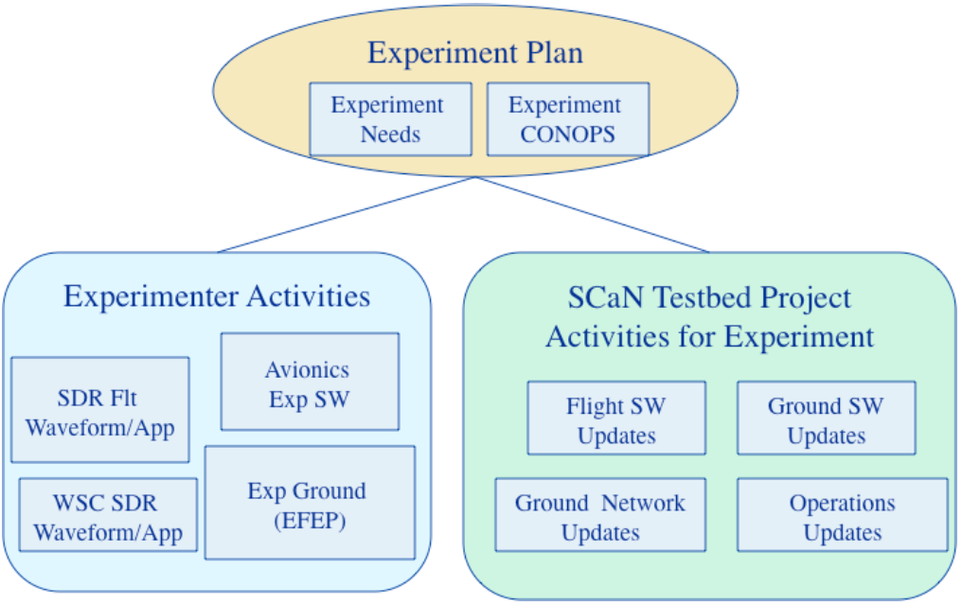

Figure -Experiment Plan diagram block concept showing the relation between the experimenter needs and ScaN Testbed project activities for the experiment

.

## Experiment Activity Requirements

The experimenter needs to have the ground station and on-orbit SDR radios to reconfigure autonomously based upon the outputs of the protocol predictor, which is fed with telemetry information, local performance measurements, and third-party databases. The reconfiguration is expected to happen as soon as a change in channel is detected in order to keep the link up and running with a minimum of predefined quality of service or to increase the link performance during favorable channel conditions.

The ground system and the avionics of the ScaN Testbed must be able to monitor and record the performance of the radios and the link during the entire experiment for post-processing by the experimenters. The output of the analysis of these performance reports might result in updates for the proposed adaptive protocol algorithm and another in-space experiment might be requested to validate the proposed changes. All the information regarding the performance reports, software updates, and experiment validation are expected to be in the final report.

Payload transmission and reception power level readings are important for the experiment operations. Even though this information is ITAR controlled the experiment only needs to know the relative power loss, i.e., the difference between the transmitter and the receiver power levels.

The experimenter team requests the evaluation of the feasibility of including TDRS 12 transmission power levels telemetry data to allow GRC ground station or ScaN Testbed to compute the relative power loss.

Also, if additional information such as radiation environment levels is publicly released it will be added to the list of the conditions under which the experiment was performed while reporting the experiment results in appropriate technical papers, journals, and conferences.

During the ground test phase described below the experimenter team requests that the performance metrics be recorded in the same manner as planned during the on-orbit experiment runs for benchmarking purposes.

## ScaN Testbed Project Requirements

The main requirement for software integration is to have remote access to the JPL breadboard breadboard systems to implement the early revisions of the adaptive MAC protocol from a workstation at Penn State.

The main requirement for the experiment execution is the need for recording the quantitative metrics during ground test and during on-orbit operations in both the ground station and ScaN Testbed for post-processing and analysis of the adaptive protocol performance for improving the overall data link performance under different channel conditions.

# Key Events Summary

## Project Phases (Design, Development, Ground Test, On-Orbit Test)

1. Experiment Design

In this phase, the main predictive and adaptive functions and mechanisms of the proposed MAC protocol are defined together with the channel description. Also the Experiment Plan describing the experiment execution, performance metrics, and other technical details such as software code development is completed.

1. Experiment Development

During this phase the algorithm for the proposed MAC protocol will be developed. While in the development phase, in case the experimenters team receive measurements of the channel, requested to ScaN Testbed project through a separate document, those will aid in the accuracy of the channel model used in improving the protocol design. An effort will be made to make the protocol compliant with the CCSDS recommendations. During this phase, if the experimenter team identifies the need for the addition of any mechanism not previously described on the Project Experiment Proposal or in this Experiment Plan, we will coordinate with the ScaN Testbed project team during the bi-weekly conferences or through another documentation request.

1. Implementation, Integration, and Ground Test

During this phase the software implementation of the algorithm will be done through coding the protocol to the specific software used by the radios FPGAs.

After implementation, the integration and ground test will occur with the support of the ScaN Testbed project technical support to make sure that the radios perform as expected during the algorithm design and development phases.

During ground testing, the experimenter team requests that the performance metrics be recorded in the same manner as expected for the on-orbit experiment runs for benchmarking purposes against the on-orbit experiment runs with the protocol feature turned on and off.

1. On-orbit Operations

During this phase the on-orbit test will occur. During each test already described in this Experiment Plan, performance metrics will be recorded at both communicating nodes, ground station, and ScaN Testbed for post-processing by the experimenter team. Depending on the results, improvements might be suggested by software updates and requests of another on-orbit experiment run in order to validate the changes.

The on-orbit experiment is divided into three experiments:

1. Experiment 1: On-orbit operations for scenario 1 (closed-loop)

Communication link between ScaN Testbed and GRC ground station in S-band using S-Band GN-LGA antenna, with CSI feedback and adaptation taking place on the return link.

1. Experiment 2: On-orbit operations for scenario 1 (open-loop):

Communication link between ScaN Testbed and GRC ground station in S-band using S-Band GN-LGA antenna, without CSI feedback and adaptation taking place on the return link.

1. Experiment 3: On-orbit operations for scenario 4:

Communication link between White Sands GS and NASA GRC GS at S-band through TRDS-12.

## Key Milestones (Including Reviews)

Key milestones and expected deadlines are provided for experiment design, development, implementation and integration. For the ground testing and on-orbit operations we provide an expected date, given that the exact date will depend on the algorithm development and implementation end date and on the schedule of available time windows provided by the ScaN Testbed project team upon coordination with the ground station facilities at GRC and White Sands.

Table -Key milestones and expected completion dates

|  |  |  |
| --- | --- | --- |
| **Task #** | **Milestones** | **Dates** |
| **-** | **Starting date** | **11/13/2014** |
| 1 | Experiment Plan | 05/01/2015 |
| 2 | Experiment Development and test on experimenter development system | 10/01/2016 |
| 3 | Implementation, Integration and Ground Test |  |
| - | Implementation and Integration | 02/28/2017 |
| - | Ground Test | 03/31/2017 |
| 4 | Experiment Readiness Review | 04/30/2017 |
| 5 | On-orbit operations Scenario 1 (S-band closed-loop) | 05/31/2017 |
| 5 | On-orbit operations Scenario 1 (S-band open-loop) | 05/31/2017 |
| 5 | On-orbit operations Scenario 4 (Ka-band closed-loop) | 06/30/2017 |
| **-** | **Completion date** | **07/31/2017** |
| 6 | Final report | 09/01/2017 |

## Deliverables

Description of the deliverables according to the Task # above:

Task 1:

* Experiment Plan

Task 2:

* Report containing algorithm description of intelligent MAC protocol and results from tests on experimenter development system.

Task 3:

* Pre-flight/test software components
* Experiment software Test Plan
* Experiment Test Procedures
* NPR 7150.2 Compliance Matrix
* Application Software Design Description Document

Task 4:

* Flight Software components
* User’s guide
* Version Description Document
* STRS-required artifacts/documentation

Task 5:

* Test participation

Task 6:

* Final report on the development, implementation, integration, testing, and on-orbit performance of predictive and adaptive mechanisms for the proposed intelligent MAC protocol.
* Included as attachment to the final report will be one copy of all conference papers, journals or other publication previously reviewed for public release.

## Dependencies

In case the on-orbit SDR radios avionics used for this experiment are not capable of monitoring and recording the requested performance metrics, the experimenter team requests the analysis and evaluation of the viability of updating the avionics software for this experiment such that the recording of the metrics and delivery to GRC and White Sands ground stations for post-processing will be possible. The same requirement is requested for the ground station.

## Ground Resource Test Schedule Plan

Scheduling of ground resources for implementation, integration, and testing will be coordinated with the ScaN Testbed project team through the bi-weekly phone conferences or any other form of contact with their office.

## On-Orbit Experiment Schedule Plan

Scheduling of ground resources for implementation, integration, and testing will be coordinated with the ScaN Testbed project team through the bi-weekly phone conferences or any other form of contact with their office. For the moment, the experimenter team agrees that it will not happen until March 2017.

Technical details regarding special time windows and analysis of desired positions between the ScaN Testbed and TDRS will be discussed and provided in advance for the ScaN Testbed project team through phone conferences.

# Experiment approach by phase

## Development and Test Approach

### Activity Description

The development approach for this experiment is divided into two main phases: algorithm development and software implementation. After the software implementation a test of the implementation in the FPGA will be performed before the integration and ground testing at the GRC facilities.

### Development and Test System Configuration

The development configuration process is shown in Figure 17. The algorithm development will be done at the Wireless Innovation Laboratory at WPI. The FPGA implementation, testing, simulation and verification will done at the Penn State Systems Design Laboratory (SDL).

Based on the channel modeling and channel measurements available by the development phase, and prediction techniques, the MAC protocol algorithm will be developed and tested using MATLAB. The design may change according to feedback given by the ScaN Testbed program through the bi-weekly phone conferences or during the software implementation in the FPGA.

In terms of hardware development, we are going to be using the NI-PCI5640R, which contains a Xilinx Virtex-II Pro (XC2VP30) FPGA onboard.  This FPGA is slightly better than the Virtex-II FPGA boards on-board the JPL radio.  According to [18] from NASA, the JPL radio is a Virtex-II FPGA with 3M gates.  If we look at Xilinx Virtex-II family product line found in [19], there is only one Virtex-II with 3M system gates -- the XC2V3000.  Based on this information, our XC2VP30 and their XC2V3000 are of similar specs with ours being a little bit better across the board than theirs.  Thus, we plan to design slightly under the full capacity of our XC2VP30, which will then fit nicely on the JPL XC2V3000.

The Harris radio uses Virtex-IV FPGAs, so these will be much more powerful than the Virtex-II in the JPL radio.  Therefore, if our design works for the JPL radio, then, if needed, porting it over to the Virtex-IV should be relativity straight forward.

For the software implementation, the experimenter team will use SystemVerilog/VHDL code for the waveform development. For FPGA simulation/verification, we plan to use Mentor Graphics ModelSim, Xilinx ISE Simulator (ISim), and/or Mathworks HDL Verifier.  The MATLAB HDL Verifier allows us to simulate/verify HDL code using Simulink/MATLAB models as opposed to having to write HDL test benches. For software development on the JPL GPP, C/C++/Python will be used. The SPARC processor found in the JPL GPP will be simulated in a Linux virtual machine environment. As development progresses, the HDL code and GPP code will be ported to the JPL Breadboard systems at the GRC facility.

After the algorithm implementation in the FPGA, it will be integrated with the ground SDR radios allowing the ground testing to be performed.

In summary:

* **Primary Development Hardware**: NI-PCI5640R (Xilinx Virtex-II Pro XC2VP30)
* **Primary Hardware Description Language**: SystemVerilog/Verilog
* **Primary HDL Verification Software**: Mentor Graphics ModelSim / Xilinx ISE Simulator (ISE)

Optionally, if the ScaN Testbed project team agrees to extend the implementation in order to utilize the all of the performance of each radio, different algorithms might be developed and simulated independently. By taking advantage of all of the FPGA hardware on the four Virtex-IV slices on the Harris radio (and breaking full compatibility with the algorithms on the JPL radio), it will be necessary to simulate Virtex-IV FPGAs and then implement it when we have access to the Harris breadboard system.

If both teams, ScaN and the experimenters, decide to take advantage of the general purpose processor (i.e., to do faster floating point) on the JPL radio, we plan to use a virtual machine on a Penn State workstation running the RTEMS OS to develop and test scripts.  Once again, this is only if we decide we want to break full compatibility between the JPL and Harris radio algorithms.  However, we do not plan to use the general purpose processor on the Harris radio as this uses VxWorks as its primary operating system and VxWorks is a very expensive proprietary OS.

For this optional cases we may use:

* **Optional Development Software**: Virtual Machine running RTEMS OS
* **Optional HDL Verification Software**: Mathworks HDL Verifier

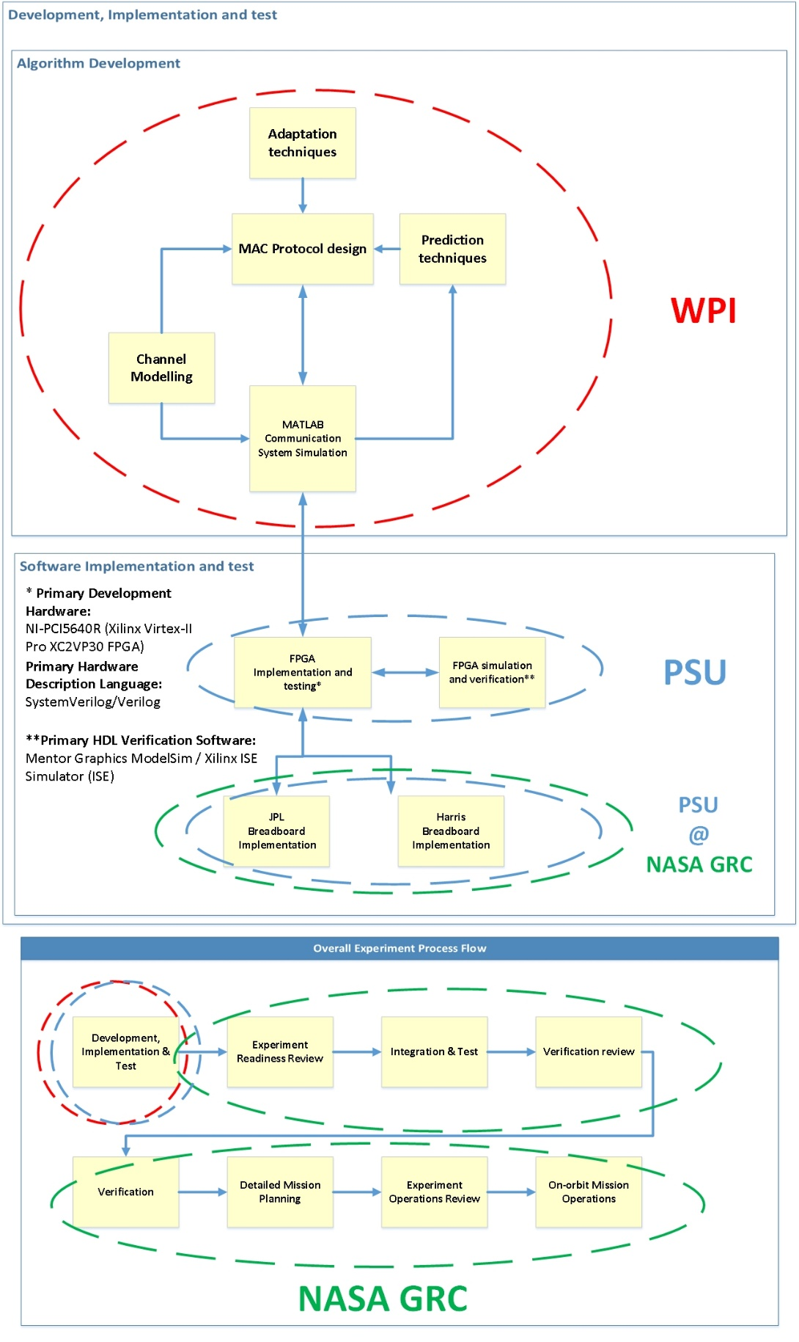

Figure -Development configuration diagram block showing the general role of the experimenter team within the overall experiment process flow and development location. The main activities are algorithm development and software implementation. The experimenter’s team will be involved with all parts of the process flow.

### Resources Requested from ScaN Testbed

For the algorithm development phase the resources requested from the ScaN Testbed are ionospheric measurements, provided through a separate document, in order to increase the accuracy of the channel. Also a bi-weekly phone conference with the ScaN Testbed project team is requested in order to keep track of the development and to solve technical issues related to the ScaN Testbed elements involved with this experiment. Additional technical support may be requested in case a specific issue is identified and reported to the ScaN Testbed project team.

The experimenter team requests the evaluation of the TDRS 12 feature of including its transmission power level telemetry data to allow the GRC ground station or ScaN Testbed to compute the relative power loss. We justify this need so that the protocol, while using the TDRS as one communicating node, will evaluate only the link TDRS-ScaN Testbed and through the closed-loop approach, evaluate TDRS transmitted power and compute the relative power loss, which is the parameter the protocol will be expecting.

For the software implementation phase the experimenter team requests the following documents for the JPL radio:

* Operating Environment FPGA Component Interfaces (D-47936)
* Operating Environment Operator’s Guide (D-47937)
* CoNNeCT Baseband Processor Module Prototype User Guide (D-49217)
* Operating Environment Integrator’s Guide (D-63241)
* Data Interface Description (D-63245)
* Space Telecommunications Radio System Operating Environment Development Environment (D-63258)

The following documents are requested for the overall development:

* Space Network User’s Guide (450-SNUG)
* STRS Definition and Concepts (NASA/TM-2008-215445)
* STRS Software Architecture Concepts and Analysis (NASA/TP-2008-214813)
* Space Telecommunications Radio System (STRS) Architecture Standard (STRS-AR-00002)
* SCAN Testbed Flight and Ground Description (GRC-CONN-DOC-5022)

Finally, any other documentation related to the implementation of waveforms and algorithms on the JPL radio on the SCaN testbed will be requested.

For the algorithm testing phase the experimenter team requests that prior to on-orbit testing a test be performed using the ground equipment to establish a benchmark. Also, during every test is requested that a communication link be established under almost the same channel conditions with the proposed protocol features turned on and off to allow for performance comparison.

Another requirement is that both the ground station and the ScaN Testbed avionics monitor and record the performance of the SDR radios for post-processing evaluation.

### Equipment/Personnel Location

During the algorithm development the experimenter team requests technical support from the ScaN Testbed project team regarding communication and capabilities information of TDRS and ScaN Testbed and additional reference documentation.

During the algorithm development the experimenter team requests access to NASA GRC facilities/equipment and all related software development tools required to use the JPL Breadboard systems, as well as the SCaN Testbed ground system.

During the test the experimenter team requests access to the ground SDR equipment performance report in order to analyze the protocol performance.

Additionally, we request access for at least one member of the experimenter’s team to be present at GRC during the on-orbit testing.

### Schedule

Ground test and on-orbit experiment run schedule will be coordinated with the ScaN Testbed project team through the bi-weekly phone conference upon completion of integration, for the test phase, and delivery of the readiness review for the on-orbit experiment run.

### Software Plan Information

The Software Class E+ requirement matrix approach is provided in Table 8.1. Many of the Software Management Plan requirements, plus other requirements, can be satisfied using the contents of this Experiment Plan.

In case of changes in the requirements during the experiment phase, those will be communicated immediately to ScaN Testbed project team to start an agreement between the experimenter team and ScaN Testbed project team on the best approach that meet the requirements of both parts. The communication might be done on the bi-weekly phone conferences or e-mail communicating the change and requesting a meeting/conference if needed.

a.) During the development phase of this project, the software will be configuration managed using Subversion. The Subversion server is located at Penn State. The software will be configuration managed using Subversion either hosted at NASA GRC or Penn State depending on which is desired by the GRC personnel. Before Verification and Validation testing, the software will be already uploaded to GRC Subversion.

b.) This experiment does NOT use any safety critical software.

Table –NPR 7150.2A Requirements

|  |  |  |  |
| --- | --- | --- | --- |
| **NPR 7150.2A Requirement Number** | **Requirement Wording** | **Minimum Requirements for non-Avionics flight software** | **This Experiment's Approach** |
| SWE-001 | This NPR shall be applied to software development, maintenance, retirement, operations, management, acquisition, and assurance activities started after its initial date of issuance [SWE-001]. |  | Yes |
| SWE-013 | The project shall develop software plan(s). [SWE-013] | Experimenters need to develop a SMP and STP. The SMP may be included in the Experiment Plan. | SMP will be written post-submission of this plan. A STP will be written for the V&V test activites |
| SWE-014 | The project shall implement, maintain, and execute the software plan(s). [SWE- 014] | Experimenters need to implement and maintain a SW development schedule. | Development schedule maintained weekly via team meetings. |
| SWE-015 | The project shall establish, document, and maintain at least one software cost estimate and associated cost parameter(s) that satisfies the following conditions: [SWE-015] a. Covers the entire software life cycle. b. Is based on selected project attributes (e.g., assessment of the size, functionality, complexity, criticality, and risk of the software processes and products). c. Is based on the cost implications of the technology to be used and the required maturation of that technology. | Experimenters need to provide one cost estimate, covering the entire life cycle, based on size, complexity. The cost estimate may be included in the Experiment Plan. | Included in this plan, see Section 5.6 |
| SWE-016 | The project shall document and maintain a software schedule that satisfies the following conditions: [SWE-016] a. Coordinates with the overall project schedule. b. Documents the interactions of milestones and deliverables between software, hardware, operations, and the rest of the system. c. Reflects the critical path for the software development activities. | Experimenters need to provide a software development schedule. The schedule may be included in the Experiment Plan. | Included in this plan, see Section 7.0. |
| SWE-018 | The project shall regularly hold reviews of software activities, status, and results with the project stakeholders and track issues to resolution. [SWE-018] | Experimenters need to support a requirements review to confirm understanding of SCaN Testbed and the SDR along with a test readiness review | Yes |
| SWE-019 | The project shall select and document a software development life cycle or model that includes phase transition criteria for each life cycle phase (e.g., formal review milestones, informal reviews, software requirements review (SRR), preliminary design review (PDR), critical design review (CDR), test readiness reviews, customer acceptance or approval reviews). [SWE-019] | Minimum set: internal V&V, integration with our GIU, V&V on GIU | Minimum set is planned. |
| SWE-020 | The project shall classify each of system and subsystem containing software in accordance with the software classification definitions for Class A, B, C, D, E, F, G and H in Appendix E. [SWE-020] | Choose E for waveforms and similar, Choose C if the SCaN Testbed’s Avionics software will need to be modified. | Class E+ |
| SWE-021 | If a system or subsystem evolves to a higher software classification as defined in Appendix E, then the project shall update its plan to fulfill the added requirements per the Requirements Mapping Matrix in Appendix D. [SWE- 021] | Experimenters to meet requirement as written | Yes |
| SWE-022 | The project shall implement software assurance per NASA-STD-8739.8, NASA Software Assurance Standard. [SWE- 022] | Experimenters shall implement software assurance per organization guidelines. | TBD |
| SWE-023 | When a project is determined to have safety critical software, the project shall ensure that the safety requirements of NASA-STD-8719.13, Software Safety Standard, are implemented by the project. [SWE-023] | If the software is safetycritical , it is Class C. | N/A |
| SWE-028 | The project shall plan software verification activities, methods, environments, and criteria for the project. [SWE-028] | Experimenters shall address these items in the STP | Will be in STP |
| SWE-029 | The project shall plan the software validation activities, methods, environments, and criteria for the project. [SWE-029] | Experimenters shall address these items in the STP | Will be in STP |
| SWE-030 | The project shall record, address, and track to closure the results of software verification activities. [SWE-030] | Experimenters to meet requirement as written | Yes |
| SWE-031 | The project shall record, address, and track to closure the results of software validation activities. [SWE-031] | Experimenters to meet requirement as written | Yes |
| SWE-049 | The project shall document the software requirements. [SWE-049] | Experimenters to document requirements in electronic format readable by NASA. | The MAC protocol on each radio (JPL) will have requirements doc. |
| SWE-053 | The project shall collect and manage changes to the software requirements. [SWE-053] | Experimenters to provide summary of changes to NASA. | Bi-monthly status and/or change request to requirements document |
| SWE-062 | The project shall ensure that the software code is unit tested per the plans for software testing. [SWE-062] | Experimenters to provide results of unit testing to NASA. | Test results will be made available to project. |
| SWE-063 | The project shall provide a Software Version Description document for each software release. [SWE-063] | Experimenters to document version number of the executable software, data integrity checks for the executable code, open problem reports with workarounds | VDD is planned. |
| SWE-065 | The project shall establish and maintain: [SWE-065] a. Software Test Plan(s). b. Software Test Procedures. c. Software Test Reports. | Experimenters to provide test plan and test reports | STP, Procedure docs, Test Reports docs |
| SWE-066 | The project shall perform software testing as defined in the Software Test Plan. [SWE-066] | Experimenters to provide test results. | Test results will be provide from the as-run test procedure |
| SWE-068 | The project shall evaluate test results and document the evaluation. [SWE- 068] | Experimenters to provide test results. | Will be Test Report doc |
| SWE-069 | The project shall document defects identified during testing and track to closure. [SWE-069] | Experimenters to provide list of problem reports with workarounds | Will use tracking system, such as GNU Redmine |
| SWE-077 | The project shall complete and deliver the software product to the customer with appropriate documentation to support the operations and maintenance phase of the software’s life cycle. [SWE-077] | Experimenters to provide a user guide or operations manual, licenses for any licensed software, version description | Users Guide will be provided. Licensed cores may require new agreements for new users. |
| SWE-079 | The project shall develop a Software Configuration Management Plan that describes the functions, responsibilities, and authority for the implementation of software configuration management for the project. [SWE-079] | Experimenters to develop a SW CM Plan that ensures code is under CM control; may be just a section of the SW Management Plan (or Experiment Plan) | Included in this plan, see Section 5.7. |
| SWE-080 | The project shall track and evaluate changes to software products. [SWE- 080] | Experimenters to provide summary of changes to NASA and notify NASA of any changes that threaten the schedule. | Experiment Status meetings. For significant updates, the appropriate documents will be updated and signed off. |
| SWE-081 | The project shall identify the software configuration items (e.g., software documents, code, data, tools, models, scripts) and their versions to be controlled for the project. [SWE-081] | Experimenters to identify the software configuration items | VDD will contain this information. |
| SWE-085 | The project shall establish and implement procedures for the storage, handling, delivery, release, and maintenance of deliverable software products. [SWE-085] | Experimenters to develop a release process for delivering software products to NASA or NASA may develop one in which case this requirement goes away | Included in this plan, see Section 5.7. |
| SWE-102 | The Software Development or Management Plan shall contain: [SWE- 102] a. Project organizational structure showing authority and responsibility of each organizational unit, including external organizations (e.g., Safety and Mission Assurance, Independent Verification and Validation (IV&V), Technical Authority, NASA Engineering and Safety Center, NASA Safety Center). b. The safety criticality and classification of each of the systems and subsystems containing software. c. Tailoring compliance matrix for approval by the designated Engineering Technical Authority, if the project has any waivers or deviations to this NPR. d. Engineering environment (for development, operation, or maintenance, as applicable), including test environment, library, equipment, facilities, standards, procedures, and tools. e. Work breakdown structure of the lifecycle processes and activities, including the software products, software services, non-deliverable items to be performed, budgets, staffing, acquisition approach, physical resources, software size, and schedules associated with the tasks. f. Management of the quality characteristics of the software products or services. g. Management of safety, security, privacy, and other critical requirements of the software products or services. h. Subcontractor management, including subcontractor selection and involvement between the subcontractor and the acquirer, if any. i. Verification and validation. j. Acquirer involvement. k. User involvement. l. Risk management. m. Security policy. n. Approval required by such means as regulations, required certifications, proprietary, usage, ownership, warranty, and licensing rights. o. Process for scheduling, tracking, and reporting. p. Training of personnel, including project unique software training needs. q. Software life-cycle model, including description of software integration and hardware/software integration processes, software delivery, and maintenance. r. Configuration management. s. Software documentation tree. t. Software peer review/inspection process of software work products. u. Process for early identification of testing requirements that drive software design decisions (e.g., special system level timing requirements/checkpoint restart). v. Software metrics. w. Content of software documentation to be developed on the project. x. Management, development, and testing approach for handling any commercial-off-the-shelf (COTS), government-off-the-shelf (GOTS), modified-off-the-shelf (MOTS), reused, or open source software component(s) that are included within a NASA system or subsystem. | Experimenters to include schedule, life cycle, cost estimate (non-University only), software and hardware environment, software and hardware tools, V&V plan (may be separate document), training plans, CM plan in Experiment Plan. | This plan, forthcoming Software Test Plan, and VDD will contain requested information. |
| SWE-116 | The Software Version Description shall identify and provide: [SWE-116] a. Full identification of the system and software (i.e., numbers, titles, abbreviations, version numbers, and release numbers). b. Executable software (i.e., batch files, command files, data files, or other software needed to install the software on its target computer). c. Software life-cycle data that defines the software product. d. Archive and release data. e. Instructions for building the executable software including, for example, the instructions and data for compiling and linking and the procedures used for software recovery, software regeneration, testing, or modification. f. Data integrity checks for the executable object code, and source code. g. Software product files (any files needed to install, build, operate, and maintain the software). h. Open change requests and or problem reports, including any workarounds. i. Change requests and/or problem reports implemented in the current software version since the last Software Version Description was published. | Experimenters todocument versionnumber of theexecutable software,data integrity checks forthe executable code,open problem reportswith workarounds | This information will be provided in the VDD |
| SWE-120 | For those cases in which a Center or project desires a general exclusion from requirement(s) in this NPR or desires to generically apply specific alternate requirements that do not meet or exceed the requirements of this NPR, the requester shall submit a waiver for those exclusions or alternate requirements for approval by the NASA Headquarters’ Chief Engineer with appropriate justification. [SWE-120] | Experimenters to meet requirement as written | Waivers are not anticipated for this Experiment. |
| SWE-121 | Where approved, the requesting Center or project shall document the approved alternate requirement in the procedure controlling the development, acquisition, and/or deployment of the affected software. [SWE-121] | Experimenters to meet requirement as written | Alternate requirements are not anticipated for this Experiment. |
| SWE-125 | Each project with software components shall maintain a compliance matrix against requirements in this NPR, including those delegated to other parties or accomplished by contract vehicles. [SWE-125] | Experimenters to meet requirement as written C | Compliance matrix will be submitted at Experiment Readiness Review. |
| SWE-132 | The project’s software assurance organization shall perform an independent classification assessment. [SWE-132] | Experimenters to meet requirement as written | Will provide information as requested. |
| SWE-133 | The project, in conjunction with the Safety and Mission Assurance organization, shall determine the software safety criticality in accordance with NASA-STD-8739.8. [SWE-133] | Experimenters to meet requirement as written | Will provide information as requested. |
| SWE-139 | Centers and projects shall fully comply with the “shall” statements in this NPR that are marked with an “X” in Appendix D consistent with their software classification. [SWE-139] | Experimenters to meet requirement as written | Yes |
| SWE-140 | When the requirement and software class are marked with a “P (Center),” Centers and projects shall meet the requirement with an approved non-null subset of the “shall” statement (or approved alternate) for that specific requirement. [SWE 140] | Experimenters to meet requirement as written | Yes |

## Verification and Validation Approach

### Activity Description

This activity will verify in-ground the individual performance of the predictive and adaptive mechanisms in light of the requirements to improve and sustain robust communication under varying channel conditions. Both MATLAB and just FPGA code will be verified to make sure that the proposed design was properly coded in MATLAB and that this MATLAB code was properly translated into FPGA code.

After the integration phase the performance reports requested from both transmitter and receiver stations for the ground equipment will be tested to assure that the protocol works in the real system and that the information requested is delivered in the proper way. The experimenters’ team expect to test the controls of turning on and off the protocol features, the telemetry response and the closed-loop functionality.

The Test Plan document, to be delivered by the end of task 3, will aid in the verification activities.

This successful completion of this activity will result in the benchmark for the on-orbit experiment. After verification and validation of the software, the code will be delivered in a hard media to be defined by the ScaN Testbed project.

The final version to be flown should be used in the formal Verification and Validation testing on the Ground Integration Unit.

### V&V System Configuration

The verification and validation activities might be performed for the following radios:

1. JPL SDR;
2. GRC ground station SDR;
3. White Sands ground station SDR;

### Resources Requested from ScaN Testbed

In order to perform the ground testing the experimenters’ team request access to the ground equipment including the SDR radios and channel emulators. Before the integration phase, if a channel emulator is to be made available, the experimenters’ team also request access to the channel emulator documentation to aid in the parameter specifications, which will be described in reports and might be used as benchmark against performance of the on-orbit runs.

### Equipment/Personnel Location

For the software implementation in the FPGA access to NASA GRC will be requested.

The experimenters’ team request technical support for integration and ground testing as well as in operating the ground stations in White Sands and GRC ground facilities.

### Schedule

Ground test will be coordinated with ScaN Testbed project team through the bi-weekly phone conference upon completion of the integration, for the test phase, and delivery of the readiness review for the on-orbit experiment run.

### Software Plan Information

The results of the verification and validation, including unit testing, will be shared through a formal document write-up distributed to the project team. The results covered in this document will include a list of defects found during the testing along with evidence showing that the defects have been addressed by correcting the problem or developing a workaround. In the first stage of verification (verification by experimenter with SCaN Testbed Project oversight) the experimenters will be responsible for documenting and addressing the defects during verification. During the second stage (integrated system tests conducted by the SCaN Testbed Project team with oversight by the experimenter), the experimenters will be responsible for supporting the documentation and addressing the defects found.

Software will be delivered by uploads to a SCaN Testbed project website. Each delivery will include a delivery manifest identifying the files, which the SCaN Testbed project computer software configuration item (CSCI) they form a part of, and any non-standard build processes needed to create a loadable image.

Loadable images will be created by project staff using the standard build process using libraries and tools from the SCaN Testbed reference repository.

## On-orbit Operations Approach

### Activity Description

The on-orbit activities represent the main part of the entire experiment, where performance data must be collected for performance evaluation through post-processing. The outcomes of the data analysis may originate changes in the algorithm code or in the FPGA code. If this happens the experimenters’ team will request another experiment run for validation.

### On-Orbit System Configuration

The on-orbit experiment consists of three scenarios, as described in the previous sections.

On-orbit Experiment 1: The Experiment 1 consists of running the experiment for the scenario 1 with closed-loop, by implementing the proposed protocol in the GRC GS, which generates radio adaptation commands to be executed by the on-orbit JPL SDR through the S-band GN-LGA antenna. Adaptation is expected to take place on the return link only, which may also convey feedback information to the GS.

On-orbit Experiment 2: The Experiment 1 consists of running the experiment for the scenario 1 with opened-loop, by implementing the proposed protocol in the GRC GS, which generates radio adaptation commands to be executed by the on-orbit JPL SDR through the S-band GN-LGA antenna. Adaptation is expected to take place on the return link only, without feedback information to the GS.

On-orbit Experiment 3: The Experiment 3 consist of running the experiment for the scenario 4 by implementing the proposed protocol in the White Sands and GRC ground stations. Communication through a GEO TDRS satellite might allow experimentation with the proposed algorithm under latency and signal attenuation due to rain fading at Ku-band.

### Resources Requested from ScaN Testbed

Link performance metrics: It will be requested the following expected values during the scheduled experiment contact times for the transmitters and receivers described in the three scenarios described above (GRC-ScaN Testbed, ScaN Testbed-TDRS, TDRS-White Sands): relative SNR (or Eb/No) between transmitter and receiver, BER, throughput and latency at the receiver, as well as transmitted power levels and bandwidth at the transmitter.

As described before, it is expected the delivery of the metrics recorded by the ground stations and the ScaN Testbed avionics for post-processing. Assistance will also be requested to access these files and interpret the information.

It is expected that ground stations and on-orbit stations will be available to support the implementation and experimentation of the proof-of-concept prototype system.

### Equipment/Personnel Location

No additional equipment is requested for the on-orbit experiments. The experimenters’ team request that the ScaN Testbed project guide the experiment runs following up with the responsible technical staff.

### Schedule

Several passes are desired to be available for the three experiment runs in order to allow a fair comparison under similar conditions of relative ISS position as well as antenna elevation angles and ionosphere conditions. The schedules will be coordinated with the ScaN Testbed project team and will be included in future updates of this Experiment Plan document.

### Software Plan Information

A Software User Manual will be provided with the adaptive MAC application which contains the information below:

a. A list of files included and what they do

b. Installation instructions

c. A list of any new command and parameter options

d. A list of any new telemetry items and their significance

e. How to operate the software. A description of its capabilities and options

f. Contact information for software problems

## Results Dissemination Phases

A combination of conference papers, journals, posters, and presentations will be done after review by NASA Headquarters through the Space Communications and Navigation Technology and Standards Division. Also these materials will be part of the final report.

# Appendix A Acronyms and abbreviations

Table Acronyms

|  |  |
| --- | --- |
| **Acronym** | **Definition** |
| ACM | Adaptive Coding and Modulation |
| APSK | Asynchronous phase-shift keying |
| ARIMA | Autoregressive integrated moving average |
| ATM | Asynchronous Transfer Mode |
| BER | Bit error rate |
| CCSDS | Consultative Committee for Space Data Systems |
| CDMA | Code division multiple access |
| CDR | Critical design review |
| COTS | Commercial-off-the-shelf |
| CSMA/CA | Carrier sense multiple access with collision avoidance |
| CSMA/CD | Carrier Sense Multiple Access With Collision Detection |
| DBPSK | Differential Binary phase-shift keying |
| ECI | Earth-Centered Inertial |
| FDMA | Frequency division multiple access |
| FEC | Forward error correction |
| FPGA | Field-programmable gate array |
| GEO | Geosynchronous orbit |
| GN-LGA | Ground network low gain antenna |
| GOTS | Government-off-the-shelf |
| GPP | General purpose processor |
| GRC | Glenn Research Center |
| GS | Ground station |
| HDL | Hardware description language |
| ISS | International Space Station |
| ITAR | International Traffic in Arms Regulations |
| IV&V | Independent Verification and Validation |
| JPL | Jet Propulsion Laboratory |
| Ka-HGA | Ka-band high gain antenna |
| LOS | Line of sight |
| MAC | Medium Access Protocol |
| MOTS | Modified-off-the-shelf |
| NASA | National Aeronautics and Space Administration |
| NOAA | National Oceanic and Atmospheric Administration |
| OE | Operating environment |
| PDR | Preliminary design review |
| Penn State / PSU | The Pennsylvania State University |
| QAM | Quadrature amplitude modulation |
| QPSK | Quadrature phase-shift keying |
| RTEMS | Real-Time Executive for Multiprocessor Systems |
| RTOS | Real-time operating system |
| Rx | Receiver radio |
| ScaN | Space Communications and Navigation |
| SDL | Systems Design Laboratory |
| SDR | Software-defined radio |
| SMP | Software management plan |
| SN-LGA | Space Network low gain antenna |
| SRR | Software requirements review |
| STP | Software Test Plan |
| SVDD | Software Version Description document |
| SW CM Plan | Software configuration management plan |
| TDMA | Time division multiple access |
| TDRS | Tracking and Data Relay Satellites |
| Tx | Transmitter radio |
| VM | Virtual machine |
| WPI | Worcester Polytechnic Institute |
| WSC | White Sands Center |

# Appendix B TBDs and TBRs

## List of TBDs

|  |  |
| --- | --- |
| Page # | Item |
| 11 | Finalizing set of modulation schemes to be employed by adaptive/predictive MAC protocol (DBPSK, QPSK, 16-QAM, 64-QAM, 8-PSK, 16-APSK, 32-APSK). |
| 26 | Organizational guidelines at WPI and Penn State need to be identified in order to satisfy SWE-022. |

## List of TBRs

|  |  |
| --- | --- |
| Page # | Item |
| 5 | Finalize configuration of experiment to contain either one or two ground stations (White Sands, NASA GRC, both). |
| 5 | Define full-link reconfigurability or half-link reconfigurability. |

# References

|  |  |
| --- | --- |
| [1] | T. Yucek and H. Arslan, "A survey of Spectrum Sensing Algorithms for Cognitive Radio Applications," *IEEE Communications Surveys and Tutorials,* vol. 11, no. 1, pp. 116-130, 2009. |
| [2] | A. Morello and V. Mignone, "DVB-S2: The Second Generation Standard for Satellite Broad-Band Services," *Proceedings of the IEEE,* vol. 94, no. 1, pp. 210-227, 2006. |
| [3] | J. Kurose and K. Ross, Computer Networking A Top-Down Approach,, Pearson Education, 2013. |
| [4] | S. Chen, T. R. Newman, J. B. Evans and A. M. Wyglinski, "Genetic Algorithm-Based Optimization for Cognitive Radio Networks," in *IEEE Sarnoff Symposium*, 2010. |
| [5] | E. Hossain, D. Niyato and D. Kim, "Evolution and Future Trends of Research in Cognitive Radio: a contemporary Survey," *Wiley Wireless Communications and Mobile Computing,* vol. 15, pp. 1530-1564, 2013. |
| [6] | A. He, K. k. Bae, T. R. Newman, T. R. Garddert, J. Kim, K. Menon, L. Morales-Tirado, J. Neel, Y. Zhao, J. H. Reed and W. H. Tranter, "A Survey of Artificial Intelligence for Cognitive Radios," *IEEE Transactions on Vehicular Technology,* vol. 59, no. 4, 2010. |
| [7] | D. M. Roijers, P. Vamplew, S. Whiteson and R. Dazeley, "A Survey of Multi-Objective Sequential Decision-Making," *Journal of Artificial Intelligence Research,* vol. 48, pp. 67-113, 2013. |
| [8] | N. Abbas, Y. Nasser and K. E. Ahmad, "Recent Advances on Artificial Intelligence and Learning Techniques in Cognitive Radio Networks," *EURASIP Journal on Wireless Communications and Networking,* 2015. |
| [9] | M. Bkassiny, Y. Li and S. K. Jayaweera, "A Survey on Machine-Learning Techniques in Cognitive Radios," *IEEE Communications Survey and Tutorials,,* vol. 15, no. 3, pp. 1136-1159, 2013. |
| [10] | S. Chatzinotas, B. Ottersten and R. D. Gaudenzi, Cooperative and Cognitive Satellite Systems,, Elsevier Academic Press, 2015. |
| [11] | S. K. Sharma, S. Chatzinotas, J. Grotz and B. Ottersten, "Implementation Issues of Cognitive Radio Techniques for Ka-band (17.7-19.7 GHz) SatComs," in *7th Advanced Satellite Multimedia Systems Conference and the 13th Signal Processing for Space Communications Workshop*, 2014. |
| [12] | M. Kutner, C. Nachtsheim and J. Neter, Applied Linear Regression Models. 4th Ed., McGraw Hill, 2004. |
| [13] | C. Chatfield, The Analysis of Time Series, Chapman & Hall/CRC, 2004. |
| [14] | O. C. Ibe, Fundamentals of Applied Probability and Random Processes, Elsevier, 2005. |
| [15] | A. Leon-Garcia, Probability and Random Processes for Electrical Engineering, Addison-Wesley, 1994. |
| [16] | S. Miller and C. Donald, Probability and Random Processes With Applications to Signal Processing and communications, Elsevier, 2004. |
| [17] | P. V. R. Ferreira and A. M. Wyglinski, "QoS Improvement For LEO-based satcom At Ka-Band," *IEEE Transactions on Aerospace and Electronic Systems,* 2016. |
| [18] | P. V. R. Ferreira, A. M. Wyglinski and R. Paffenroth, "Interactive Multiple Model Filter for Land-Mobile Satellite Communications at Ka-Band," *IEEE Access,* 2016. |
| [19] | T. M. Hackett, S. Bilen, P. V. R. Ferreira, R. Paffenroth, A. M. Wyglinski and R. Reinhart, "Implementation of a Parameterized Interacting Multiple Model Filter on an FPGA for Satellite Communications," in *34th AIAA International Communications Satellite Systems Conference*, Cleveland, Ohio, 2016. |
| [20] | I. Guvenc and K. Ulas, Reliable Communications for Short-range Wireless Systems., Cambridge University Press, 2011. |
| [21] | J. Cai, "Power Allocation and Scheduling for Ultra-Wideband Wireless Networks," *IEEE Transactions on Vehicular Technology,* vol. 57, pp. 1103-1112, 2008. |
| [22] | W. Baek, Reliable and Power Efficient Protocols for Space Communications and Wireless Ad-Hoc Networks, University of Southern California, 2006. |
| [23] | K.-H. Li, "An adaptive MAC protocol for satellite ATM," in *15th International Conference on Information Networking*. |
| [24] | T. Ors, "Analysis of an adaptive random/reservation MAC protocol for ATM over satellite," in *IEEE 48th Vehicular Technology Conference*, 1998. |
| [25] | M. Emmelmann and H. Bischl, "An adaptive MAC layer protocol for ATM-based LEO satellite networks," in *IEEE 58th Vehicular Technology Conference*, 2003. |
| [26] | J. P. Choi and V. W. S. Chan, "Adaptive communications over fading satellite channels," in *IEEE International Conference on Communications*, 2001. |
| [27] | J. D. Huba and G. Joyce, "Global modeling of equatorial plasma bubbles," in *GEOPHYSICAL RESEARCH LETTERS*, 2010. |
| [28] | J. D. Huba and G. Joyce, "Global modeling of equatorial plasma bubbles," *Geophysical research letters,* vol. 37, 2010. |
| [29] | NASA, "Space Communications and Navigation," NASA ScaN Testbed, [Online]. Available: http://spaceflightsystems.grc.nasa.gov/SOPO/SCO/SCaNTestbed/Candidate/documents/PS-00958%20SCaN_Trifold.pdf. |
| [30] | Xilinx, "Xilinx Viterx-II Series FPGAs," Xilinx, [Online]. Available: http://www.xilinx.com/publications/matrix/virtexmatrix.pdf. |